Pacific Northwest Station of
The Cruising Club of America
Minutes of the Monthly Meeting October 4, 2023

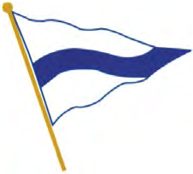

The meeting was called to order at 1230 hours at the Seattle Yacht Club by Secretary/Treasurer Susan Stillman assisted by John Robinson.

In Attendance: Susan and Charlie Stillman, John and K Robinson, Ryan Helling,
Kappy and Tom O’Brian, Paul Baker and Suzette Connelly, Chris and Shawn Otorowski, Don and Sherry Stabbart, Jon, Ann and Deveren Bowman, Jenna Miller and Jamie Utzschneider, Bruce Johnston, Jim and Barbara Cole, Michael Gropp, Peter Powell,
Gary Meisner, Adam and Lorna Seamans, Brent and Jill Peterson, Roger and Lynne Werner, Joe Golberg, Rusty, Joyce and Tad Lhamon, Brian Duchin, Howard and Stephanie Conant, Rick and Maureen Meslang, Steve Leonard, Chuck and Peggy Steward, Gary Nolan, Tom White, Stacey Wilson, Gil Middleton
Guests: Nick Brown, Peggy Wiltse, Nick Browne, Dan Kerns and Chris, Bob Eichler

In Attendance by Zoom: Doug Adkins, Roddy, Jill and Rod Hearne, Mary Alice O’Neill, Phil Swigard, Baird Tewksbury, Alli Bell

John Robinson opened the Meeting
He welcomed our guests and the Zoom participants.

New Members
Joe Golberg introduced Jenna Miller and Jamie Utzschneider
Gary Meisner introduced Adam Seamans and his wife Lorna.

Jenna, Jamie and Adam received burgees and a tie or scarf as desired.

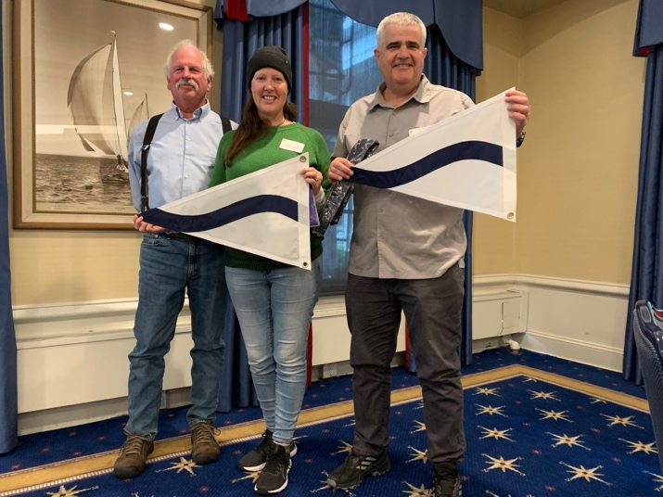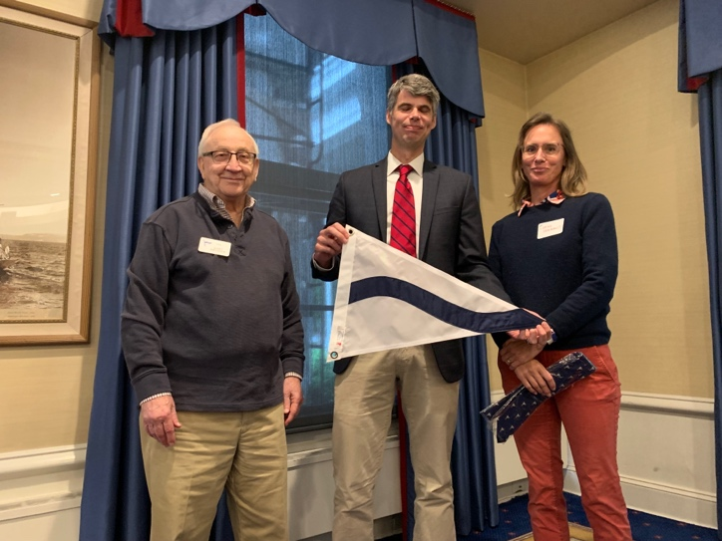
Bonnell Cove Foundation
Joyce Lhamon reported on the Fall Meeting Board meeting. It lasted 3 hours. Bonnell Cove Foundation is a nonprofit associated with CCA. It provides financial support by providing grants to nonprofit organizations focused on conservation and education. Out of 16 applicants, requesting $151,000, nine received funding for a total of $45,000. Bonnell Cove is overwhelmed with good funding candidates. 100% of your donation goes to the recipients. Please donate! BTW the refunds to the Mallorca Cruise totalled $39,000. Joyce has resigned as president. Bob Medland is now the president of Bonnell Cove. Look out for more worthy non-profits. Charlie Stillman is also on the Board. He and Joyce can answer questions.

Safety for Cruising Couples Workshop—John Robinson
46 people are signed up for the workshop at Seattle Yacht Club next weekend.
In spring there will be another presentation of the program and they are hoping for one to take place in Bellingham. A leader for that presentation is needed.

Safety Minute—Jamie Utzschneider
Brand new member Jamie Utzschneider told the experience he had. He lives on Owl, their tug on Lake Union. It was a calm sunny day. He observed an overloaded SeaDo jet ski pontoon boat zipping along. Then in a sudden turn, they buried the bow and flipped the boat! He had Jenna call the Harbor Patrol and dinghied over. Under the boat there were people holding on. Jamie helped one who could not swim. They didn’t have life jackets.

ICOYC and Fall Meeting Report—Bruce Johnson
Bruce reported on our recent acceptance for membership in the International Council of Yacht Clubs. The organization puts together international cruises which our members are now eligible.

Bruce attended the Fall Meeting in Lunenburg, Nova Scotia. Bruce and Stacey Wilson are the official chairs of the 2025 Fall Meeting. There was a cruise on the Bluenose and about 90 people in attendance. For the 2025 meeting they have already lined up local charter companies. Prior to the meeting there will be a great local cruise. Already he has lined up charters

Cruise Reports by Suzette Connolly and others
John Kennell sent in the following: We’re still in Europe, currently making our way down the North Sea towards Holland with former Seattle Times photographer Harley Soltes and his wife Susie onboard their 47 cutter “Prudence”. Return October 10, so regrettably will miss the meeting and Historical Report. Will see you in November.

Having returned this week from the CCA cruise around the island of Mallorca with the Hearnes, Susan Stillman reported that they are entertaining guests during their last few days in Palma and preparing Keewaydin to be shipped off to Florida, thence via the Panama Canal back to her home waters while the Hearnes visit Morocco.

Doug Cole is visiting the Schiblis at Daphne Island. They head back to Starfire at Gilbraltar next week. Then Brazil, Cape Town and Australia this season.

Bill and Kathi Cuffel have returned to Jarana, still moored at Preveza near the Corinth Canal.

Jim and Barbara Cole attended the meeting but also sent the following summary of their 2023 cruising: We visited friends in Bodrum, Turkey on our way to Leros Island in the Greek Dodecanese Islands. After recommissioning the boat we sailed across Greece with stops at gorgeous islands in the Aegean, Peloponnesus and Ionian Seas. We then cruised Albania, Montenegro and Croatia in the Adriatic. We enjoyed a bit of land travel in all three countries. We left the boat in a marina near gorgeous Kotor, Montenegro for a longer Balkan road trip visiting Bosnia and Herzegovina, Serbia, Romania, Bulgaria, North Macedonia and Kosovo. We then sailed across the Adriatic Sea to Brindisi, Italy. We went from there to Rome by train to pick up our new life-raft, see some friends and take in some of the sights such as the Coliseum and Vatican. We sailed south to Siracusa on Sicily then on to Malta where we left the boat in a dry berth for the winter. Our travels included 13 countries this season.

Howard and Stephanie Conant, having wintered Soul Mate in Cobb's Marina Virginia yard. SM was prepared for a rigorous cruising season in late March and April. We headed north to cruise the Hudson River, Erie Canal to Lake Ontario and into the Saint Lawrence waterway a short way to the Thousand Islands. We visited Boldt Castle for an entire day. Cruisers can tie up to the Castle dock free of charge if they draw about five feet or less. From the Castle we reversed course on the Canadian side, heading west toward Kingston after checking in at Gananoque. Kingston was crowded so we proceeded up the Rideau Canal and lake and river system to Ottawa for the Canada Day celebration on July 1. The Ottawa River took us to Montreal. The villages and scenery were charming, quiet and reminiscent of past times. The Richlieu River and Canal led us to Lake Champlain, the Champlain Canal and back to the Hudson. This loop is sometimes called the Little Loop, and is sure worth the trip, certainly over 2,000 miles.

Eight Bells
Doug Adkins joined the meeting from his home on Orcas Island to ring 8 bells for member Jim Day.

Spring Cruise Report—Joe Golberg
Joe showed photos of the cruise from Secret Cove to Princess Louisa Inlet where the club had docks mostly to themselves. A highlight was the men’s appetizer competition served a-top on overturned inflatable dinghy.

Mallorca Cruise—Chris Otorowski, Susan Stillman, K and John Robinson
With the island’s map projected, Chris outlined the course of the circumnavigation. We took turns narrating stories of the trip with photos showing shopping for provisions in local markets, group events, harbor views, dramatic cliffs, historic stone watch towers, local flamenco dancing and lots more.

Respectfully submitted,
Susan Stillman
CCA/PNW Secretary/ Treasurer

Zoom link:
https://us02web.zoom.us/rec/share/b74hB95txED4L6WuXoTQLN_99wCEcqVysZOIywuUuuqQ6b1o3wsmPOThx5HhXT5K.eMJs_kGvsDG-Q8i6

Passcode: .tB#TK6T

