Pacific Northwest Station of
The Cruising Club of America
Minutes of the Monthly Meeting December 6, 2023

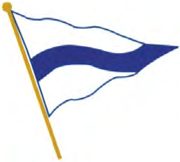

The meeting was called to order at 1230 hours at the Seattle Yacht Club by
Commodore Dave Utley

In Attendance:
Jon, Ann and Deveren Bowman, Pat Carey, Elaine Cashar, Jim Cole,
Howard and Stephanie Conant, Paul Baker and Suzette Connelly,
Jim and Sue Corenman, Bill and Kathi Cuffel, Michael Gropp,
Wendy Hinman, Gil Middleton, Jenna Miller, Gary Nolan, Tom O’Brien,
Warren Perkins, Brent and Jill Peterson, John and K Robinson,
Dan and Kathy Schwartz, Alex Simanis and Elishia, Dave Utley,
Roger and Lynne Werner, Dick and Allie Bell

Guests: Dan Kerns, Dick and Sally Bell

In Attendance via Zoom: Phil Swigard, Joe Golberg, Rod Hearne, Doug Adkins, John Kennel, Kent Powley, Mary Alice O’Neill, Richard Meslang, Doug Cole, Peter Brown

Dave Utley opened the Meeting at 12:30pm
He welcomed attendees, guests and the Zoom participants.

This was Dave’s final meeting as Commodore. National dues are going up to $240/year and may be paid via the website. This amount reflects a 3% increase from $24 over 100 years.

Election of New PNW Station Bridge

Sue Corenman motioned to accept the new slate of officers for the chapter and was seconded. Unanimous yea approved the new slate of officers as follows:

Doug Adkins – Rear Commodore
Susan Stillman – Membership Chairperson
Roddy Hearne – Secretary/Treasurer

Cruise Reports by Suzette Connolly and others

Sunny and Margie of Hoptoad have some projects in San Carlos so unable to attend.
Bill and Kathi Cuffel’s boat is in Tunisia and they plan to cruise in Sicily and beyond next year.
Jim Cole’s boat is on the hard in Malta

Secretary and Treasurer by Susan Stillman
She is unable to attend, doing sea trials of a possible new boat

Membership by Doug Adkins
Have 4 applications, letters are being asked for, to be reviewed in February, so please send in the letters.
Asking for new applications
1355 members currently.

Cruise Report – Joe Golberg

No current plans yet, the committee never sleeps

Historical Report—John Kennell

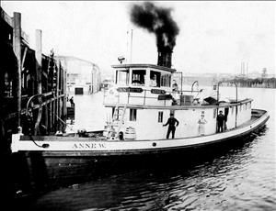
Tugboat Anne W, first sinking in the Hiram M. Chittenden Locks, plus 2 more sinkings.

Safety Minutes – Dan Schwartz

Presentation “Installed Fire Suppression: An Update”

Speaker Chair – Suzette Connelly

Suzette introduced Michael R. Hand Sr, Lock Master at the Hiram M. Chittenden Locks, also known to some of us as the Ballard Locks. The Hiram M. Chittenden Locks we’re built 1917 by the U.S. Army Corps of Engineers who continue to operate the locks. Our locks in Seattle are the busiest locking system in the nation.
Note: Unfortunately the meeting was not recorded. Mr. Hand was not able to connect via Zoom nor provide the presentation on a thumb drive due to government regulations for his laptop and material.

The next meeting will be Jan. 10, 2024

Respectfully submitted,
Susan Stillman
CCA/PNW Secretary/ Treasurer
with Elaine Cashar, able scribe

