February 10, 2020 MEETING MINUTES

The meeting was called to order at 12:35pm by Rick Meslang.

MEMBERS AND SPOUSES PRESENT: Doug Adkins, Paul Baker and Suzette Connolly, Peter Brown and Janet McKinnon, Elaine Cashar, Doug Cole, Howard and Stephanie Conant, Phil DiNuovo, Joe Golberg, Roddy Hearne, Steve Jacobsen, John Kennell, Gary Meisner, Rick Meslang, Chrissie Marshall, Hugh and Jackie Minor, Gary Nolan, Mike O’Byrne, Brian and MayAlice O’Neill, Peter and Molly Powell, Mark Roye, Charlie and Susan Stillman, Sonny Solsig, Dave Utley and Roger Wheelis and Berit Kenin.

GUESTS: Chris Utley with his father Dave, Tom Harper with Doug Cole

MARINE WEATHER SYMPOSIUM: The CCA will be holding a marine weather and sea state symposium on Feb. 29, 2020 at The Seattle Yacht Club. The program will began at 0830 and end around 1730. The Station has sponsored two younger sailors for the seminar and it promises to be a full and instructive day.

MEMBERSHIP: Our station has five new membership proposals at this time, They will be reviewed in March and confidential comments can be posted on the website. If you have a candidate in mind please let Membership Chairman Dave Utley know as soon as possible.

FALL MEETING 2020: Our station will be hosting the 2020 Fall Meeting on Oct. 22,23,24. Chairman Susan Stillman expects 120-150 people to attend. She reports that the entire agenda will be posted on the CCA website following the Annual Meeting in NYC in March.

CRUISERS:
Rob Hurlow is checking his boat somewhere in the Pacific. The Stabberts are in Honolulu aboard Starr, the senior Hearnes are back aboard Look Far in Bonaire counting more fish and Phil Swigert is “cruising” across the United States aboard his Mercedes Benz Sprinter.

SECRETARY/TREASURER: Doug Adkins reported that:
The station is solvent..but it won’t be unless all members pay their annual station dues of $40. Only about half have paid! Please send them to him at
1200 Fifth Avenue,
Suite 1725
Seattle, WA 98101 THANKS

CRUISE CHAIRMAN: John Pedlow was not with us but please keep in mind that the dates for this year’s cruises will be:

Spring Cruise: May 10 thru 17- Start in Roche Harbor and end at Rosario Resort

Fall Cruise: September 11 thru18- Destination to be determined

FUTURE MEETINGS: There will be no meeting in May because of the Spring Cruise. Our final meeting before the summer break will be in June.

SPEAKERS: Peter Brown and Howard Conant described our line-up for the March and April Meetings. Randell Reeves will speak to us regarding his Figure 8 tour of the Americas in March and Jacques White will tell us about salmon on April with his address regarding the conservation work of “Long Live The Kings.”

SAFETY MOMENT: Mark Roye spoke about the Southeast Alaska VHF Communication and the present concerns regarding the inoperable Repeater NET. He urged sailors to use both their VHF and cellphones in the case of an emergency and to employ HF Single Sideband as well. An important reminder is to repeat position at least three times, both for the recipient of the call and for any third party listeners. He also reminded us of the importance of a handheld VHF in the event of a liferaft situation. The attached handout will provide additional data.

Mark also responded to a question regarding NOAA’s transition to all electronic chart storage and provided advise regarding printing out charts and chartlets from the web.

HISTORIAN: Doug Adkins made his final report and happily announced that the Station’s Fourth Historian is the irrepressible John Kennell. He reported that on this day in history we celebrate the birthdays of:

Lon Chaney, 1906
Laura Dern, 1967
Mark Spitz, 1950
Roberta Flack, 1939
Robert Wagner, 1930
Jimmy Durante, 1893
Shirley Temple Black, 1914
Joseph Lister, 1912
Arthur Miller, 1905
And our own Joe Golberg who was born on February 29th and will celebrate his 18th birthday later this month!

Other notable events:

On this date in 1943 Vesta Stoudt, an ordinance plant worker in Chicago, sent a letter to President Roosevelt suggesting the production of a cloth backed tape for sealing ammunition boxes. Fast to put on, easily torn by hand, unpacking under fire made easy. FDR liked the idea and duck tape was born.

In 1962 the British, French and Spanish signed the Treaty of Paris to end the French and Indian War, and then the real fighting began!

In 1962 downed U-2 pilot Farncis Gary Powers was swapped for Senior KGB spy Col. Rudolf Abel in a celebrated exchange of prisoners.

The Historian’s Report finished with a history of cannon balls and appropriate deck stacking systems for rapid deployment and stable locating.

YOUNG MEMBER LIASON REPORT: Roddy Hearns serves as the National Coordinator and our station’s representative to the Young Member Committee. The aim of the committee is to explore ways in which the CCA can attract more new members under the age of 55 with activities and programs which will appeal to sailors in that cohort. He will meet at the Annual Meeting to discuss initiatives and report back to the Station.

PROGRAM: Peter Brown and Doug Cole served up our speaker, PNW member Peter Powell who led us through his extraordinary travels as pilot of his Citation nine-place jet with stops in Canada, Greenland, Iceland, Ireland, Minorca, Malta, Egypt, Djibouti, Ethiopia, Jordan, South Africa, Mozambique, Rwanda, Greece and other exciting venues. The tour with three other aircraft and took about eight weeks and consumed 9500 gallons of jet A-1. The wildlife and historic shots were terrific.

Rick Meslang adjourned the meeting at 1400 hrs.

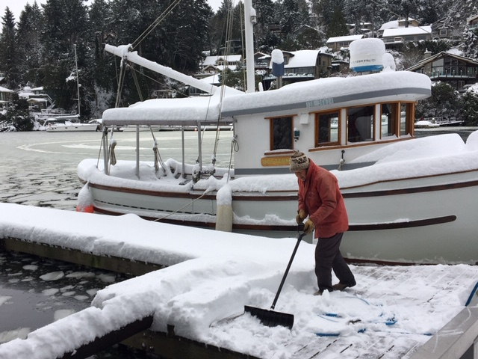
Kaspar on “Our Favorite Dock” at Daphne Isle. What a difference a few months makes!

Respectfully submitted,
Douglas Adkins, Sec/Treas

