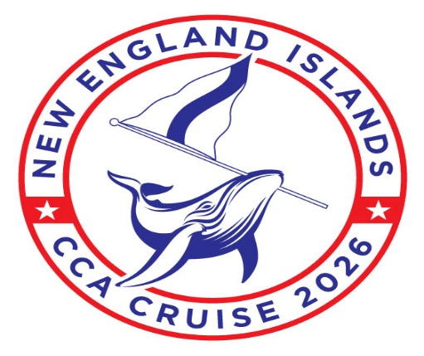

New England Islands Cruise Marinas/Moorings
All Reservations are made through Dockwa www.Dockwa.com

Reservation
Location Provider Opening Date/Time Type

Newport Oldport Marine April 1 8:00am Mooring
Safe Harbor Newport Shipyard Open Dockage
Cuttyhunk Town of Gosnold Open Dockage
Inner Harbor March 15 8:00am Mooring
Outer Harbor Open Mooring
Martha’s Vineyard Edgartown Harbormaster February 19 10:00am Dockage
March 2 8:00am Mooring
Nantucket Nantucket Moorings March 16 8:00am Mooring
Nantucket Boat Basin TBD Dockage
New Bedford Pope’s Island Marina April 1 8:00am Dockage/Mooring
Whaling City Moorings TBD Mooring

