Cruising Club of America, San Francisco (SAF) Station
Meeting Minutes

Meeting Date: January 11, 2023
Location: Pt. San Pablo Yacht Club, Richmond, CA
Guests: Kame Richards, guest of Jim Antrim; Dick Woodbury, guest of Mary Crowley; Ray Lynch, guest of John Swain; Marco Misbach, guest and son-in-law of Zia Ahari; Aaron Wangenheim, guest of Doug Finley; Peter English, guest of Terry Klaus; Cliff Shaw and Randy Leisure, guests of Jim Quanci.
Call to Order: New R/C Schaper called the meeting to order at approximately noon and thanked Past R/C Quanci for the excellent job that he performed during the past two years.
Venue Suggestions: R/C Schaper called for suggestions for possible meeting venues during 2023. Members suggested a number of possible lunch meeting locations including the: San Francisco YC, Encinal YC, Berkeley YC, South Beach YC, Santa Cruz YC, S.S. Red Oak Victory, California State University, Maritime Academy, San Francisco Maritime Museum and some restaurant venues. There will be two dinner meetings at the Spaulding Wooden Boat Center in May and the St. Francis YC in December. R/C Schaper will consider the lunch suggestions.
Treasurers’ Report: New Treasure, Synthia Petroka, reported that she is organizing the Station’s banking and noted that there is approximately $1,700 in our checking account and another $7,000 that will be posted once the SAF accounts are transferred to her as treasurer.
Membership Committee Report: Maureen “Moe” Roddy reported that the SAF station should use the CCA Online Membership Applications to comment on candidate applications. Do not email Moe directly.
Safety At Sea Committee Report: Chuck Hawley was not able to attend the meeting due to unfortunate circumstances where his family beach house in Santa Cruz was damaged so badly in the series of Atmospheric River storms that Chuck was obligated to demolish the building. Stafford Keegin gave the Safety at Sea report by briefly stating that it was published once before, in 2016, and, in the interest of time, could be read in the minutes. Chuck’s report is in these minutes as Appendix B.
Awards: Outgoing R/C Jim Quanci recognized two members of the SAF station. First was Mary Crowley who will be awarded the First Annual CCA Diana Russell Award named for one of the first women members of the CCA. The Diana Russell Award recognizes innovation in sailing design, methodology, education, training, safety, and the adventurous use and enjoyment of the sea. Mary, founder of Ocean Voyages Instituted that has cleaned nearly one million pounds of plastic from the North Pacific Gyre over the past four years. As members of the SAF station know, Mary is more than deserving of this recognition.
Also recognized was Bob Hanelt, who received the Bob Van Blaricom Award for 2022. Zia Ahari read his remembrances of Bob Van Blaricom. (Attachment B.)
Environment of the Seas Committee Report: Rowena Carlson, Chair of the CCA Environment of the Sea Committee, was not in attendance so this report will be given at the February 2023 meeting.
Speaker and presentation: Mary Crowley introduced our speaker Merf Owen, naval architect and explorer who happens to be the husband of our CCA-SAF member Ashley Perrin. Merf and Ashley sailed from Newfoundland to Greenland back. These voyages were the subjects of Merf’s presentation.
Merf’s presentation is mostly contained in Appendix C, but a few interesting comments are not included so they are listed here. These comments indicate that Merf and Ashley are well-prepared sailors who are knowledgeable about the dangers and conditions of high-latitude sailing and exploration—including the danger of ice bergs. For example, Merf noted that, in their fiberglass yacht, they: installed a watertight bulkhead forward, aft of the chain locker; installed a new anchor roller and anchor; carbon-fibered the chain plates to prevent condensation seepage; and padded the interior of the hull with yoga mats for insulation and warmth among other preparations. Unsure of what and where would be their haul-out options in Greenland, they even took their own shipyard stands so they could be sure of a safe winter drydock.
Next Lunch Meeting: Our next meeting will be Wednesday, February 8, 2023, at the Sausalito Yacht Club.
SAF Member Attendees: Zia Ahari; Jim Antrim; Diane Barker; Jim Coggan; Mary Crowley; Dick Enersen; Doug Finley; Bob & Kristi Hanelt; Wyman & Gay Harris; Peter Hogg; Michael Johnson; Stafford Keegin; Terry Klaus; Stephen Mason; William & Joan Mittendorf; Michael Moradzadeh; Bruce & Lynne Munro; Alan Olson; Ashley Perrin & Merf Owen; Synthia Petroka; Mike & Susan Proudfoot; Jim Quanci and Mary Lovely; Randall Reeves; Moe Roddy; Jim Robinson; Robby and Dolores Robinson; Richard Schaper; and John Swain
Photos by Ocean Voyages Institute
Submitted by Bob Hanelt for Chuck Hawley, Secretary.

APPENDIX A:
Zia Ahari’s Memories about Bob Van Blaricom
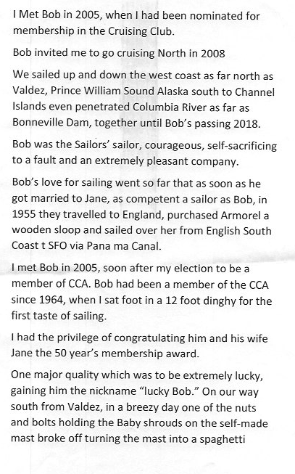

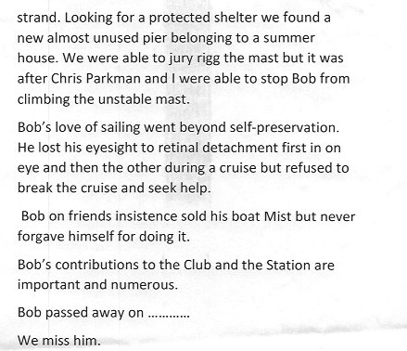
Robert A. (Bob) Van Blaricom, engineer, sailor, boat builder and author and long-time resident of Tiburon, CA passed away comfortably at home on September 20, 2019, at the age of 89.

APPENDIX B: CCA SAFETY MOMENT

New Year’s Resolutions
“Safety Moments, presented at CCA Stations and Posts”
By Chuck Hawley, San Francisco Station, January 2023
Ah, New Year’s Resolutions. So easily suggested; so quickly neglected! Lose 20 pounds, get regular exercise, reduce intake of saturated fat, and cut out that last glass of wine in the evening: we’re very good at making promises to ourselves, and then allowing them to fall by the wayside as the weeks of the new year speed by.
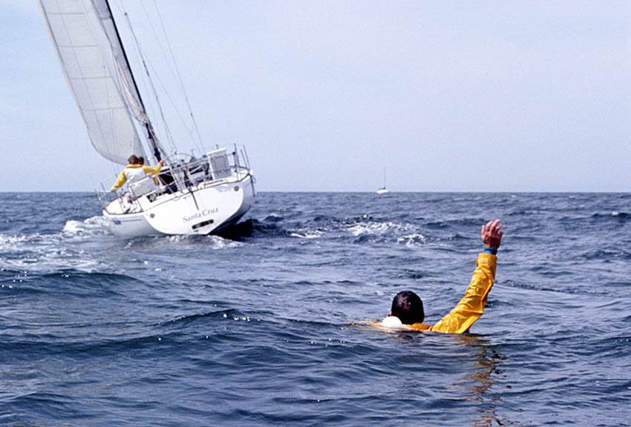
But what about the resolutions we make with regard to the safe operation of our own sailboats and cruisers? How many times have you heard a fellow voyager say “Ya know, the next time we’re out, we ought to do a man overboard drill” or “I need to post instructions for how to broadcast a Mayday in the nav station.” With full knowledge that seamanship resolutions may have the same chance of succeeding as those we make about our behavior on land, I nonetheless suggest that we resolve to do the following:
- Actually do a man-overboard drill, unannounced, with an inanimate object that vaguely simulates a person in the water. A fender and a bucket work reasonably well. Try this on a variety of points of sail, especially off the wind, where some sail adjustment is necessary so the vessel can fetch the victim. You should decide in advance if you are the “victim”, and therefore won’t participate in your own “recovery”.
You can judge the success of the exercise by the smooth operation of the boat as it returns, the control of boat speed, and a lack of direct contact with the “victim”. Is there a practical means of hoisting or reboarding the victim? Can the sails be struck to prevent the boat from sailing away? Would the rescue have been successful?
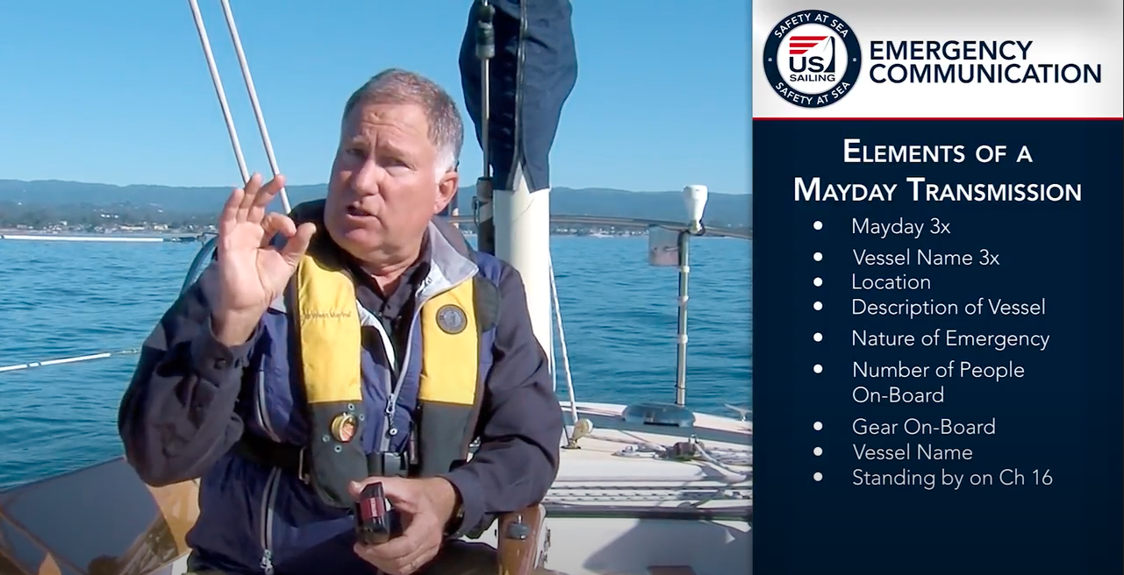
- Take the time to write down the procedure for broadcasting a Mayday or a Pan-Pan. If you’ve got a DSC-equipped radio, make sure the GPS is always on when the VHF is on, or you’ll be missing out on one of the great safety improvements of the 2000s. What is the Coast Guard going to want to know verbally? While the DSC fingerprint will provide a lot of information, a verbal description of the vessel name, nature of the incident, and number of people on board is extremely helpful to the Coast Guard.
If you don’t have a DSC-equipped radio, buy your boat a belated Christmas present and hook it up to your GPS. It’s one of the most cost-effective pieces of gear available.
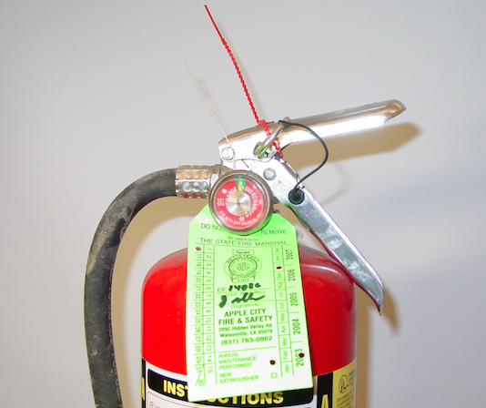
- The other piece of gear that rises to the top of the effectiveness hierarchy is either an EPIRB or PLB. I won’t go into detail about the impact these devices have made on marine safety (you can read articles on the CCA website that are very informative), but the key is that with one of these dedicated marine transmitters, you gain access to a worldwide network of professional rescue services. ‘Nuff said. Carry an EPIRB and ensure that you can get to it in an emergency.
- Check your flares, fire extinguishers, and inflatable life jackets before spring. While the need for aerial flares may be decreasing due to electronics, a three or six pack of hand flares is a damned good idea, that are dated within 42 months of their data of manufacture. Check the gauge on your fire extinguishers and invert them a half dozen times to free up the agent inside. And take the time to open up your inflatable life jackets to ensure they have a good CO2 cylinder and replace the bobbin or whatever your device uses to sense the water.
- Finally, and while I realize you all do this religiously (for some, it may be as close to religion as they actually get, but that’s a personal decision), please take the time to give your guests a pre-departure talk about what to expect before you cast off. Important items include finding out who is not a competent swimmer, who is a likely second-in-command, how the head works, and how to avoid head injuries from the boom. Yes, it takes 10 minutes from your time on the water, but it’s the sign of a conscientious skipper who cares about his or her crew, and who exemplifies the high standards of the CCA.
Happy New Year, everyone, and may your voyages, long and short, be safe and pleasant.
(Note: this is a reprint from a 2016 Safety Moment that has aged surprisingly well.)
The Cruising Club of America is a collection of accomplished ocean sailors having extensive boat handling, seamanship, and command experience honed over many years. “Safety Moments” are written by the Club’s Safety Officers from CCA Stations across North America and Bermuda, as well as CCA members at large. They are published by the CCA Safety and Seamanship Committee and are intended to advance seamanship and safety by highlighting new technologies, suggestions for safe operation and reports of maritime disasters around the world.

Appendix C: Cruising to and Exploring in Greenland
Merf Owens’ presentation focused on two recent double-handed sailing trips by him and his wife/sailing partner Ashley Perrin aboard her 30’ racer cruiser, Santana. In 2018 having won their division in the Halifax-St Pierre Miquelon Ocean Race, they delivered and hauled Santana ashore in St Johns, Newfoundland for the winter of 2018/2019 in preparation for an extended sailing expedition to West Greenland the following year.
Santana, a Carl Schumacher Capo 30 equipped for high latitude cruising, anchored in West Greenland
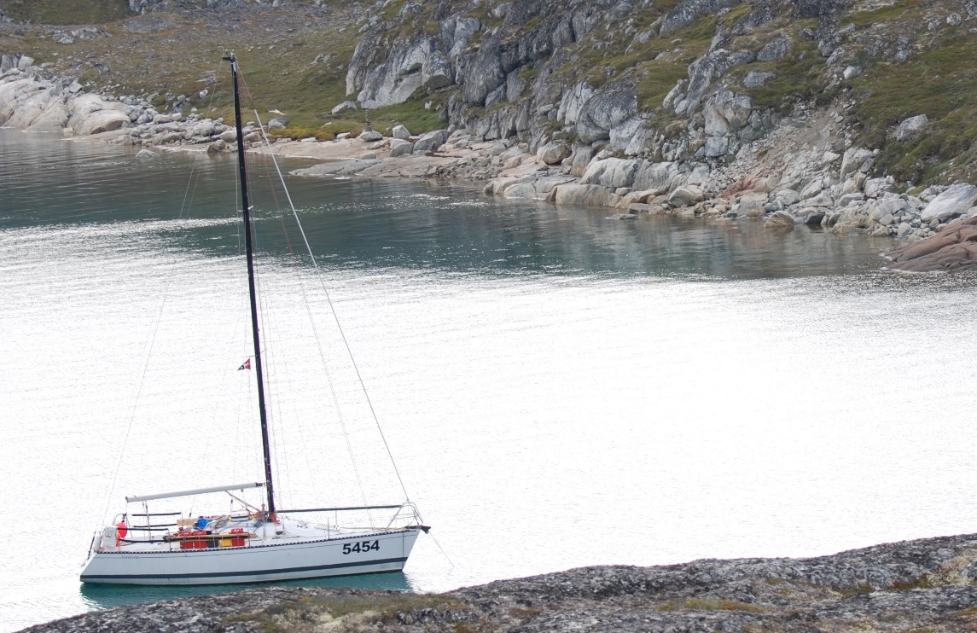
In 2020, Santana was the first boat to be launched and travel north among the icebergs of the east coast of Newfoundland, stopping at Bonavista, official site of John Cabot’s landing in North America in 1497, over a century before the Mayflower. In northern Newfoundland they visited L’Ans a Lou, the site of an 11th century Viking settlement, before leaving the fishing port of St Anthony bound for West Greenland. Five days later, after crossing the Labrador Sea, thirty miles from the coast, Santana came close to dismasting when the aluminum mast sheered into two pieces just above deck level. Sails came down and slowed to between two and four knots under motor, with wind and sea building, Merfyn and Ashley finally made safe haven fourteen hours later having endured gusts in excess of 70 kts and up to 8-meter seas. What followed was an unintentional, yet breath-taking cruise thru the inside passage, among the uninhabited islands and fjords of the west coast to Nuuk.
Santana, in a remote anchorage the morning after arriving in West Greenland on the tail of a 50kt+ storm
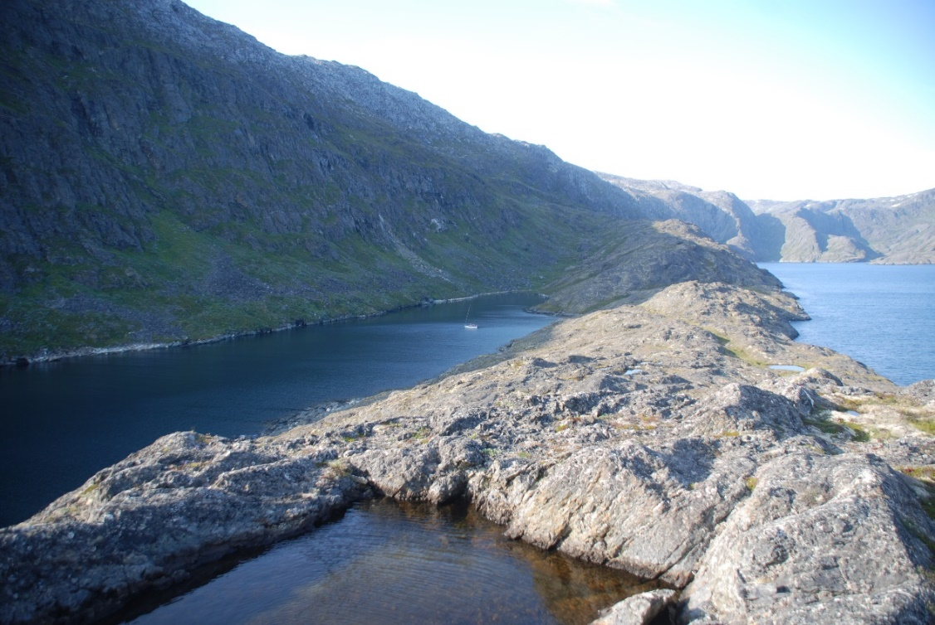
The near dismasting, cut short their summer cruise and Covid delayed a return for three winters until this year (2022) when in the Summer they were re-united with Santana. A sleeved section of mast was brought along with luggage from the U.K., and Merf and Ashely set about repairing the rig and making the passage south, Leaving Greenland too early for their liking but with a good weather window for the compromised mast and rig, their sights were set on the coast of Labrador. They were not disappointed: After a six-day crossing of the Labrador Sea they arrived on the remote coast of Labrador to warm welcomes wherever they went and the splendor of the old summer fishing grounds of the Newfoundland fleet. Truly the road less trod…in the four weeks after leaving Nuuk, meeting only six other sailing yachts before leaving Santana once more for the winter, this time on West coast of Newfoundland at the Bay of Islands Yacht Club.
Santana anchored off an abandoned fishing village in Henley Harbour/Fort York, on the Labrador coast.
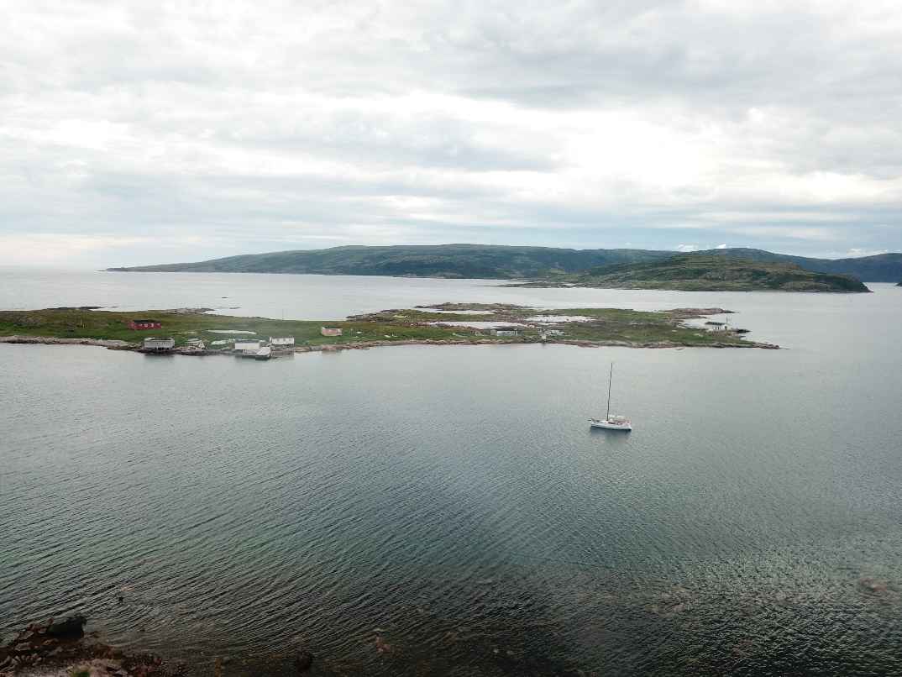
Merf’s presentation included some great photos of Greenland’s local architecture, fauna, flora and geography, pilotage and sailing notes, as well as thoughts on seamanship, boat preparation and design.
End

Merfyn Owen is a naval architect, graduate of UCL, Fellow of the University of Glamorgan, Fellow of the Royal Institute of Naval Architects, and chartered engineer. He is a founding partner of Owen Clarke Design where his roles have historically been racing yacht design and development of new projects such as the high latitude cruising yacht, Qilak. Merfyn served on the committee that created the Volvo 70 rule and sat on the IMOCA 60 technical committee for 5 years. He is a double Cape Horner and former round the world race skipper himself on the 96/97 BT Global Challenge, as well as co-skipper in the 2005 Transat Jacques Vabres and numerous Class 40 events. With over 250,000 miles of offshore sailing experience including three voyages to the Arctic, his input is also very much as ‘hands on sailor-designer’.
See Appendix A.

