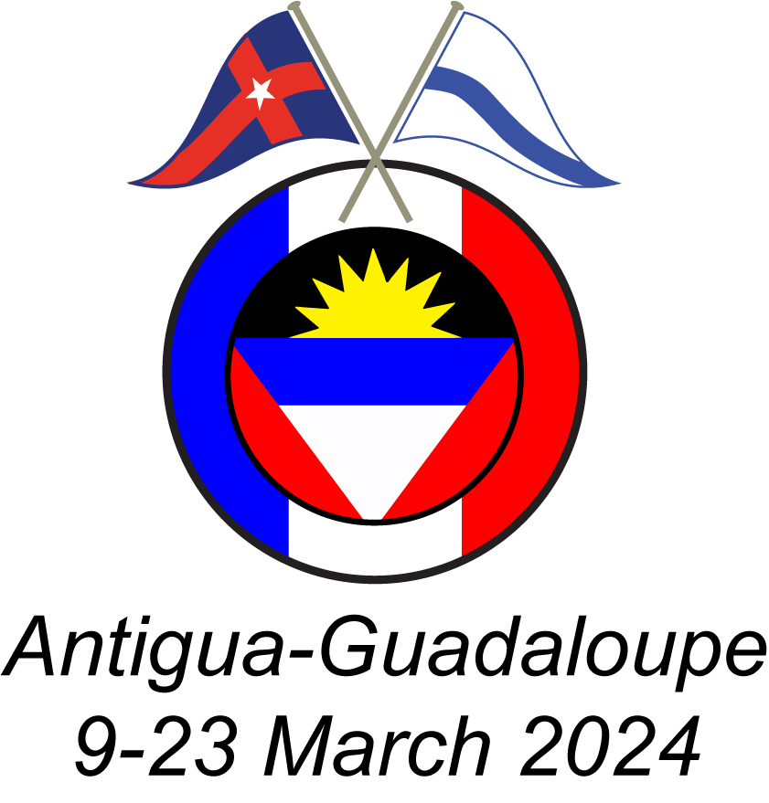

Cruise Evaluation
To: | Steve Landis, NYYC Cruising Committee Chair
From: | Doug Renfield-Miller, Antigua Cruise-in-Company Event Chair
Cc: | Nick Brown, James Boyd, Sharon Sullivan
Date: | March 28, 2024
Re: | Recent NYYC/CCA Antigua Cruise-in-Company
Our draft Cruise-in-Company Planning Guide recommends that a report be submitted to the Chair of the Cruising Committee following the completion of a cruise. Hence this report.
I’m pleased to report that overall, we had a very successful cruise. The cruise was organized as a crossed-burgee event with the CCA. The NYYC took primary responsibility for the first week of the cruise: a sail around Antigua. The CCA managed a second, optional week sailing around Guadeloupe. We had 128 individuals aboard 24 yachts participating in the Antigua week. Among the yachts, 12 were captained by joint members of both clubs, eight by NYYC-only members and four by CCA-only members. The fleet comprised 14 bareboat charters, two crewed charters and eight privately-owned yachts.
Organized events during the cruise included opening and closing dinners as well as an optional beach party (almost everyone signed up). Billed revenue totaled $61,400 and the cruise generated a small, $2,778 surplus (4.5%). Thanks go to Sharon Sullivan for managing the finances and negotiating with vendors. While there were mechanical problems with some of the charter yachts, there were no reports of injuries or other serious mishaps. However, there were some unforeseen issues and lessons learned for future cruises:
- A crossed-burgee event is challenging. The two clubs worked well together and enjoyed each other’s company, but tracking participation, billing, and conforming to each club’s policies and practices added layers of complication. One major issue is having two communication channels, one per club. In sum, joint cruising is worth doing, but the added difficulties shuld be recognized.
- One should not pre-reserve bare-boat charter boats. Use yacht broker for crewed charters only. This was well-intentioned based on a concern that there would not be sufficient yachts available. However, this increased costs and complexity and put the clubs at the center of any charter issues.
- The proposed itinerary should be vetted with any charter companies in advance. We only learned at the outset of the cruise that Moorings/Sunsail charter boats were prohibited from transiting a planned channel. Going around was not feasible given time constraints, so some charter boats had to reverse course and rejoin the fleet a Green Island.
- It is advisable to have Club staff present for at least the opening event (and ideally for the entire cruise). Registering attendees, dealing with venues, and managing logistics is challenging for the Event Chair to manage solo.
- Confirm the availability of the time and frequency for daily captain’s calls. Antigua calls conflicted with another cruising net.
- Solicit emails addresses of all participants well in advance of a cruise to ensure everyone receives bulletins with key information (e.g. links to digital Cruise Book, WhatsApp group, PhotoCircle, and Club Store).
- If music is planned for an event, ensure it is not too loud – unless dancing is planned.
- Having a Photo Circle app proved a great way to avoid the WhatsApp circuit being overwhelmed with photos. In fact, having a WhatsApp link for such cruises is essential, both for friendly chat and for needed administration.
- Having specially embroidered clothing on offer is a hallowed part of such cruises. For the NYYC, the Club Store should be solicited first to see if the desired articles are available. Further, the chosen vendor of the traditional cruise gift must be made aware that the NYYC logo cannot be used on any other item or for any other purpose.

